**St. John’s News-November 2024**

**MARK YOUR CALENDARS-NOVEMBER 17TH**

**Women’s Thankoffering Service**

**Youth’s Thanks-for-Giving Meal**

**THE SEMI-ANNUAL CONGREGATIONAL MEETING!**

***November Birthdays-*** Betsy Eardley, John Fritz, Jim Willis, Kalli Vargas, Andrea Hirt, Andrea Schwochow,

Wilma Ohms, Corey Schwochow, Oaklynn Zucker, Sandy Greunke, Peter Hilt, Evan Baker, Rose Bowers,

Becca Myers, Gary McNair, Adam Hirt, Bette Kaltenbach, Nick Bower, Jodi Baker, Terry Wilhelm, Bridget

Shiets, Ann Bixler, Sue Albrechta, Susan Sadowski, Karen Schwochow, Brantley Baker, Jacob Dagg.

***Anniversaries-*** Mike & Jodi Baker, Corey & Andrea Schwochow, Steve & Bridget Shiets, Dave & Nancy Goodman.

**LUTHER LUNCH BUNCH** will meet on Wednesday, November 20th at 12:30 PM following noontime prayers. Carol will fix turkey and dressing while others can furnish the sides. All are welcome!!

**SALAVATION ARMY BELL RINGING**

St John’s is honored to share our time to help others in our community. We’ll be ringing on Saturday, December 7th and Saturday 14th at Kroger’s from 9:00-7:00. Call Bette Kaltenbach at 419-334-2246 to sign up for one hour of heartwarming service.

The Thanks-for-Giving lunch provided by our youth, will be held on Sunday, **November** **17th**, following the 10:30 AM Service. We will be serving a chicken Casserole (a new recipe), Green Beans, Rolls, Jello Salad, and pie. ***Please let us know if you plan to*** ***attend.*** The meal is free as a thank you for all of your support in helping them go to the Youth Gathering, but please consider bringing a donation for our Blessing Box which serves those in need in our community. Our Semi-Annual Congregational meeting will follow the lunch. ***Thanks for supporting our pop-up bake sales!!*** Our profit from the Apple Dumpling Sale was $380.00!!

**WOMEN’S CHRISTMAS DINNER-**will be held on Monday, **December 16th** at 5:30 PM. The cost is $10.00 per person. Reservations need to be made through the Church Office by Sunday **December 8th**.

**GRIEFSHARE- SURVIVING THE HOLIDAYS-**  This seminar will utilize a video, workbook, and discussion to provide encouragement and support to navigate the holiday season during your time of grief. This is a separate program from our regular Griefshare and all are welcome to attend.

**St. John’s Lutheran Lounge, 212 N. Clover, Sunday, November 17,5:30-7:00 pm, Snacks and Beverages provided**

**St. John’s thanks the landscape committee for their diligence in keeping our property looking beautiful!!**

**BLUE CHRISTMAS: SUNDAY, DECEMBER 8TH AT 4:00 PM**

This is a special worship service to pause, reflect, and remember those whom we have loved and lost, holding our dear loved ones before God; giving thanks for them.

**Christmas Poinsettia Sale**

**Please fill in order blank below and return it to the church office.**

**Payment must accompany all orders.**

**(Make checks payable to St. John’s )**

**Number of plants @$12.00 each ___Enclosed___**

**Order deadline is Sunday, December 1st**

**(Please-no more than 2 names per poinsettia)**

**Name____________________________________**

**Phone_______________**

**In loving memory of (Deceased) ____________________________________**

**In honor of (Living)_____________________________________________**

**To the Glory of God____________________________________**

**St. John’s Upcoming Dates to Remember!!**

**November 3rd** –***All Saints Day***

Noon-Confirmation

1:30 PM-Rest Bible Study

**November 5th-** 6:00 PM-Executive Board

**November 10th** -12:30 PM-LIFT Board Meeting

**5:00 PM-Dinner Church**

**November 13th**- Church Council

**November 17th** -Thankoffering Sunday

11:45 AM-Thanks-for-Giving Meal

Semi-Annual Congregational Meeting-following the meal

5:30 PM-“*Surviving the Holidays”*- GriefShare

**November 22nd-** 5:00 PM-Make Buckeyes- Everyone is welcome!!

**SUNDAY SCHOOL NEWS**

Congratulations to the following children for completing the Faith Stepping Stone Program and who be receiving their Bibles on October 27:

***Abbott Boroff, Gabi McNalley, Ryze Owens, Christian Rojos, Cooper Schwochow, Hannah Wheeler, and Levi Wheeler.***

Congratulations to ***Hannah Wheeler*** who was “Student of the Month” at Lutz Elementary.

**Upcoming Events:**

**November:** We will begin practicing our songs for the Christmas Program during our Sunday School Opening (9:15 AM -9:30 AM) so that we will be ready on Sunday, December 15. Please try to have your children attend. I will also email the songs and have paper copies so you may practice at home with them.

**Saturday, December 7:** **LIFT Breakfast in Bethlehem here at St. John’s from 9:00 AM- 11:00 AM.** -The children will be learning about the birth of Jesus in Bethlehem through storytelling, crafts, games, etc. Come for breakfast, fellowship, and fun. All ages are welcome to join us! This program has been very well received in the past. Helpers (adults and teenagers) are needed to work the stations. You may call the church office or let Sue or Heather Hawn know if you are able to help.

**Saturday, December 14- Christmas Program Practice 10:00-11:00**

**Sunday, December 15- Christmas Program at the 10:30**

**MITTEN TREE:** It’s not too early to start thinking about collecting hats, scarves, gloves, and mittens for our Mitten Tree in December. We welcome all sizes. The donations are for the Fremont City School children and Blessing Box.

**Youth Events!**

**Buckeye Sale- Nov.24th**

We will be making Buckeyes

on Friday, **Nov.22nd**  **- 5:00 PM**

We need everyone’s help!! Donations & orders are due on Nov. 17th.

**THE THANKS-FOR-GIVING MEAL** will be held on Sunday, **November 17th** following the 10:30 AM Worship Service- set up will be on Saturday, November 16th at 9:00 AM.

**Salvation Bell Ringing**

Youth will ring **outside at WalMart** on Sunday, December 8th from Noon-4:00 PM.

**Sunday School Christmas Program**

**Sunday- December 15th** at the 10:30 AM Worship Service. Practice will be on **Saturday, December** **14th** from 10:00-11:00 AM



Ohio State/Michigan

**St. John’s Lutheran Youth**

**2024 Buckeye Sale**

**$6.00 a bakers dz.**

**Please pick up after each service**

**Sunday, November 24th, 2024 or Between 9:00-Noon on November 23rd.**

**Name: _____________________________________________**

**Phone: _____________________________________________**

**\*\*How many bakers doz. _________ @ 7.00 ea.**

**_______ I will donate Jif Creamy Peanut Butter or Aldi Brand Creamy Peanut Butter**

**_______ I will donate Nestles semi - sweet chocolate chips**

**_______ I will donate powdered sugar**

**\*\*orders and donations are due on Sunday, Nov. 17th!! Proceeds will go toward Youth events…**

**Thanks-for Giving Meal**

**Sponsored by St. John’s Youth**

**Nov. 17th- 11:30 AM**

**Menu -**Chicken Casserole (New Recipe)

Green Beans, Rolls, Jello Salad, Pie

**Reservations:**

**Name__________________________**

**Number Attending_______**

**Please bring a non-perishable item

For our Blessing Box, which serves

those in need in our community.

**St. Mark News!! November 2024**

**HAPPY NOVEMBER BIRTHDAY** to Trevor Carnicom, Kristina Wojdyla Reiter, Logan Garza, Lucas Garza, Randi Fielding, Lois Bradford, Adam David, Rachell Moneghan Paeth, John Bennett, Clint Hill, Danielle McClory, Margaret Wolf, and Alisha Polter Stout.

**WORSHIP HELPERS FOR NOVEMBER**

**Nov. 3:** Ushers Budd Gibbs and Colleen Carmack; Assistant Kerri Hosang; Reader Kerri Hosang; Altar Care Sue Peck

**Nov. 10:** Ushers Nancy Pullins and Kerri Hosang; Assistant Karen Heater; Reader Verna Carlo; Altar Care Sue Peck

**Nov. 17:** Ushers Nancy Pullins and Kerri Hosang; Assistant Sue Peck; Reader Sue Peck; Altar Care Kim Wojdyla

**Nov. 24:** Ushers Ritzman Family; Assistant Kerri Hosang; Reader Kerri Hosang; Altar Care Sue Peck

**MEETINGS AND EVENTS**

**WORSHIP** Sundays at 10:00 a.m. Communion served the first and third and all Festival Sundays. Fellowship follows the first Sunday service; Noisy Offering for community outreach is collected on the second Sunday.

**BLESSED BUNCH** meets Saturday, November 16 at 5:00 p.m. at the Ritzman home. There will be a light supper and a viewing of “The Chosen.” RSVP to the Ritzmans at 419-307-1048 by November 10. ALSO the Bunch will meet at 1:00 p.m. Tuesday, November 26 to decorate the church for the Advent and Christmas seasons. All are invited to the Blessed Bunch activities.

**WOMEN’S CIRCLE** will meet at 6:30 p.m. Wednesday, November 13 at the home of hostess Wendy Ritzman. At the November meeting the women will make final plans for the Women’s Thank Offering service during worship November 24. All women are invited to attend Circle meetings.

**CHURCH COUNCIL** meets at 6:00 p.m. Tuesday, November 19.

**BITS OF NEWS**

-Richard Molyet has taken over the duties of treasurer for St. Mark.

-The church basement will be painted during November; some plans may be changed. . Stay tuned for announcements.

- -St. Mark’s semi-annual congregational meeting is scheduled for November 17, following the worship service. The main item of business is the budget for 2025.

Church Council has allocated funds from the Noisy Offerings. The choices were made based on results from a survey of the congregation. Each of the following groups received $150.00:

- Sandusky County Cancer Care Fund, which is administered through United Way, provides funds for those in treatment for cancer. Funds may be used for medicine, transportation, etc.

- Fremont Soup Kitchen, held at Grace Lutheran Church.

- Backpack Buddies for students at Lutz Elementary School, a LIFT project.

- Let’s Build Beds, a workshop scheduled for September 2025, facilitated by the Women’s Circle.



**LIFT NEWS: Nov. ‘24**

*LIFT (Living in Faith Together) is a collaboration of congregations in the Fremont area, including Emmanuel, Faith, Grace, St. John’s, and St. Mark Lutheran Churches and Hayes Memorial UMC. Our mission priorities are: Being present in the community, witnessing to God’s love, hearing the needs, serving our neighbor, and striving for justice*.

**Backpack Program Enters 3rd Year**

For a third year, LIFT is working together to provide weekend hunger assistance to children at Lutz Elementary School. This year we have 28 families, which includes 95 children. We are seeking donations of kid-friendly food items in individual servings. Especially needed right now are soups, small boxes of cereal, fruit cups/applesauce, and snack crackers. Financial donations can be sent to the LIFT office at Grace Lutheran (705 W. State St. Fremont, OH 43420), with “Backpacks” in the memo. If bought individually, we have determined that each week of packing the backpacks costs $6.32 per child. We are grateful for all the support this program has received from our congregations. Contact Annette Moore - j88a62m60@aol.com.

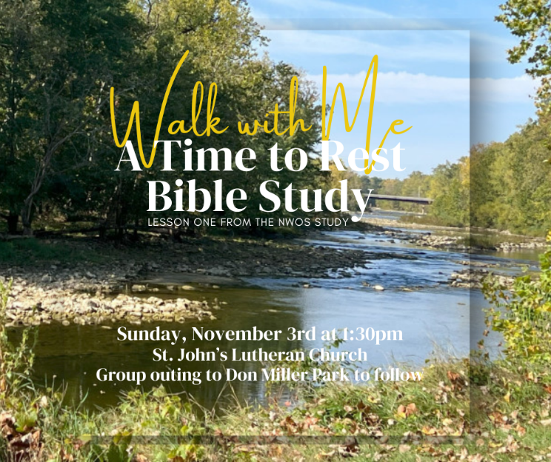

**Bible Study about Rest**

Do you feel overwhelmed? Is your life busy? Could you use some more rest? Join us November 3rd, 1:30 PM at St. John’s Lutheran church 212 N. Clover St. as we start  the Northwestern Ohio Synod’s A Time to Rest Bible Study. During this meeting we will go through lesson one, active rest, and then take a walk as a group at Don Miller Park. Questions can be directed to Pastor Matthew Wheeler- matthew.wheeler612@yahoo.com, Heather Hawn- HeatherRHawn@gmail.com, Becky Seibert- beckyseibert0@gmail.com, or Les Widmer- Widmerleslie@gmail.com.

**Farewell and Welcome**

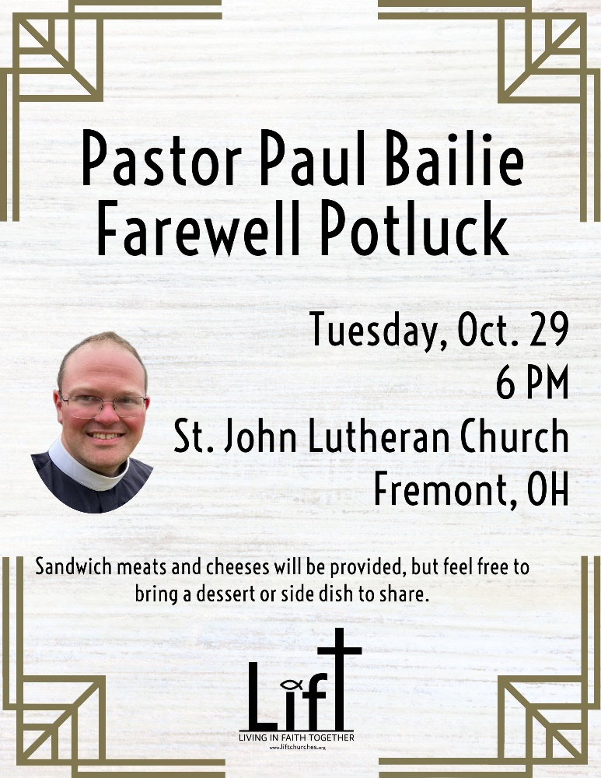Having served as LIFT pastor since 2021, **Pastor Paul Bailie** is accepting a call to serve as pastor to St. Paul and St. John Lutheran Churches in Marblehead. His last Sunday with LIFT is October 27. You are invited to a farewell potluck on Tuesday, October 29 at 6 PM at St. John’s Lutheran Church in Fremont. Sandwich meats and cheeses will be provided. You are invited to bring a dessert or side dish to share.

After much prayerful discernment, **Pastor Mary Carmen Padilla** and her husband, Leo, will be returning to their home in Monterrey, Mexico. November 24 will be their last Sunday with Camino de Vida. This unique ecumenical Lutheran-Methodist collaboration focuses on the local Hispanic population around Fremont and worships Sundays at 9:30 at Hayes Memorial UMC.

Starting in November, **Maureen Pump**, a Synodically Authorized Minister, will begin serving as Pastor Leader at St. Mark Lutheran Church. She will also continue serving at Grace Lutheran Church, where she has been on staff for many years.

**Thank You!**

Thank you to all who participated in God’s Work, Our Hands Sunday on September 15. After a meal at St. Mark, our projects included:

• Clothes sorting at Alicia’s Closet, a resource for foster families, housed at St. John’s

• Packing birthday cake kits with LIFT’s Bridge of Hope pantry at Hayes Memorial UMC

• Park cleanup at Rodger Young Park

• Christmas cards for Global Refuge (formerly Lutheran Immigration and Refugee Services) at St. Mark

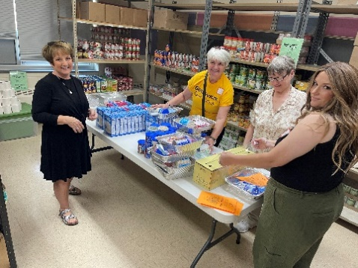 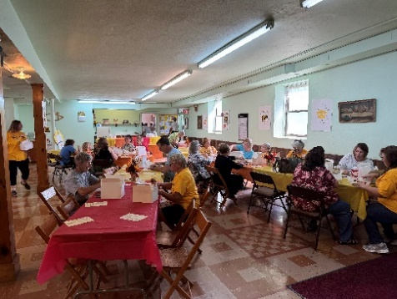 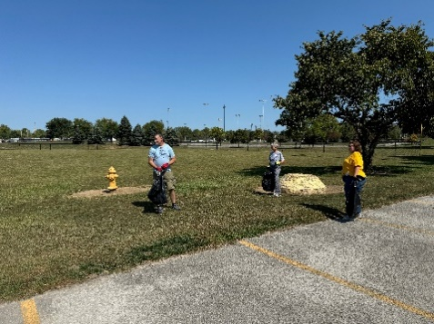

**\*\*Mark your calendars now for the Advent/Christmas Tour of Churches on December 15th from 1:00-4:00 PM. More information will be included in our next newsletter.**