**St. John’s News-April 2025**

**The Journey Ends… *by Rising***

In these April days, we listen, and hear again the stories that nudge us, move us, hold us, and invite us toward the hope our ancestors have walked. God provides water in the desert, (Isaiah 43.) Mary anoints Jesus for his burial, (John 12). Jesus humbles himself even to the point of death on a cross, (Philippians 2). And Jesus is betrayed, arrested, and mocked, fastened to a cross, the same week Jesus was praised by the people while entering Jerusalem on a donkey, (Palm and Passion Sunday). No words can compare with the three words we receive in the Gospels at Easter, “Christ is Risen!” The passion and resurrection of Christ is meant to stun us – not once, not twice. But again and again, for all of time.

The pain of death has been an abiding ache in the human heart from the beginning. For all of time, we human beings have wept with our eyelids lowered, looking for meaning. These three words at Easter then, ‘Christ is Risen,’ are worth more than everything in the world combined. ‘You may have all the rest,’ the hymn goes… ‘*Give me Jesus*.’ Christ’s love for us, a love that is greater than death, draws us deeper and deeper within, and calls us out to go deeper and deeper into the world bearing good news.

Like the tomb at Easter, there are still stones to be rolled away in this world. The heavy stone of greed in our world, seems lodged in its place. And yet, it is no match for Easter’s power. We’re freed in Christ to give generously of ourselves.

The heavy stone of fear holds us back from living into Jesus’ new commandment, ‘Love another as I have loved you,’ (John 13). The most common phrase in the Bible is, ‘Do not be afraid.’ We are freed in Christ to care, and care deeply, for the well-being of our neighbor.

The stone of envy, which blocks our sight from all that God has already given us – holding us back from living with gratitude at the center – is a stone that rolls over our souls. We become fixed (obsessed?) with all that we don’t have, or don’t seem to have. But it is a stone though that is reduced to gravel. We are freed to live with simplicity, a lighter heart, focused on kindness and compassion.

And many more heavy stones…

May we journey these days ahead with fresh eyes, journeying from Cross to Resurrection, from fear to hope, from death to new life – with Christ, in Christ, and for Christ – embracing one another, embracing Christ, embracing any who might despise us, looking for sorrows to be turned to joy and dancing and rejoicing!

Remembering the struggle, the loss, and the hope and joy of these days ahead, with you,

Pastor Matt Wheeler +

**St. John’s Mid-Week Lenten Schedule on Thursday Nights**

**Thursday, April 3rd, 7:00pm - Jesus as “Encourager”** (Homily from Synodically Authorized Minister Maureen Pump of St. Mark Lutheran Church) (Dinner at 6:00pm)

**Thursday April 10th, 7:00pm - Jesus as “Comforter”** (Homily from Pastor Matt Wheeler of St. John’s) (Dinner at 6:00pm)

**First Communion, Learning Together**

“Whenever you share this bread and cup, I will be with you, feeding you, loving you, forgiving you.” There is a place for you at God’s Table! (‘A Place for You’ first communion booklet by Daniel Erlander.) All fourth graders and their parents/grandparents/adults are most welcome to join Pastor Matt for First Communion faith formation and learning, leading up to Maundy Thursday’s service, where first communicants will be able to receive Communion, the Real Presence of Christ (April 17th). Come join us in the Parish House (Youth Group Room) the following Wednesday nights for prayer, conversation, and learning together: **+ April 2, 5-6pm + April 9, 5-6pm + April 16, 5-6pm**

Have you ever wondered how the palm crosses for Palm Sunday are made?  You can join Bette Kaltenbach and the youth Friday night, **April 11** at 6 to learn how and make them for our Palm Sunday worship service.  Please come enjoy this intergenerational activity in the Parish House auditorium!

***April Birthdays-*** Joe Albrechta, Jan Johnston, Esther Gibson, Isobel Willey, Dawn Havens, Jacob Smith,

Mike Sadowski, Josh Tooman, Lois Waggoner, Debbie Baker, Brenda Hawk, Melvin Michael, Pat

Myers, Tom Fishbaugh, Marisa Lindsay, Lisa Walther, Logan Schwochow, Josh Bower, Jerry Bower,

Connie Fishbaugh, Coal Schwochow, Meredith (Seem) Williams, Mary Lou Baker, Joyce King, Doug

Morris, Damian Heminger, Tannah Bower, Sandi Loew, Stevie Baker, Tami Hottinger, Eunice Boedeker,

Norm Kraak, Adon Rojas, Michele Gulau.

***Anniversaries-*** Bill & Gail Ebert, Phil & Cindy Tooman, Phil & Linda Willis, Mike & Susan Sadowski,

Mike & Connie Smith, Sam & Dawn Havens.

**LUTHER LUNCH BUNCH** On Wednesday, **April 16th**, we will meet at the back parking lot at 11:30 AM, where we will carpool to Bernardi’s Restaurant in Sandusky. Reservations must be made by **April 13th** by calling the church office or Carol Franks at 419-334-2963. Please be kind and make your reservations early. Any one is welcome to join us!



*From the Family of Barbara Behrendsen-* Thank you to the Funeral Luncheon Committee and those who donated food for the Luncheon. Thanks to Pastor Matt for his visits with the family for guidance. Also, we would like to thank our Church Family for prayers, cards, and thoughts of sympathy. Thanks to Maury and Mike for getting everything ready for the service and the luncheon.

WE’RE LOOKING FOR SOME VOLUNTEERS to help

Keep up the landscaping around the church property.

If you would be interested in helping this year please contact

Connie Warner- 419-355-7818 by the end of April.

**SCHOLARSHIP FUND-**Applications for Scholarship requests are now being accepted. The application to apply and the completed application may be picked up and dropped off at the church office. First-time Applicants: must be a confirmed St. John’s member for a minimum of 2 years, be active in the life of the church, and are graduating or have graduated from high school within the last five years. The application, proof of acceptance to a college or facility of advanced education, and an essay are required. Second-year and Beyond Applicants: the application and proof of enrollment in a facility of advanced education is required. Applications must be submitted by **May 15, 2025**. The Scholarships will be awarded in June, 2025.

**HOLY WEEK SCHEDULE-**

**April 13th -** Palm Sunday 8:00 & 10:30 AM Worship Services

**April 17th** - Maundy Thursday Service-7:00 PM

-4th Graders receive 1st Communion

**April 18th -** Tenebrae Service 7:00 PM

**April 20th**- Sunrise Service-6:30 AM; Easter Breakfast-7:00

Regular Sunday Services- 8:00 AM & 10;30 AM

**MEMBER SPOTLIGHT**

Who is Carol Franks, you might *not* ask, if you have been at St. John’s Church for any time. As a faithful, dedicated, lifelong member, she can be found almost everywhere. Carol has been involved with church circles for years. She is currently the "President" of Rachel/Charity Circle and does all their Bible Studies. She also helps Eunice Boedeker with organizing and serving the funeral luncheons. Carol is no stranger to the kitchen. She’s always helping serve or cooking for some luncheon, dinner, or bake sale. She also bakes cookies for her Sunday School classes on holidays.

On Sundays, you might find her at the head of the church during communion holding a tray of communion wine. After the 8:00 a.m. service, you are sure to find her in the library at the Parish House getting ready to teach Adult Sunday School which starts at 9:15. She’s no stranger to teaching, she was the head of the Elementary Sunday School Department for several years. After retiring, she saw a need for an Adult Sunday School class teacher and volunteered.  That’s Carol, she doesn’t just stop at just seeing a need, she also offers a solution which often involves her filling that need. When fellow members needed a ride to church and Sunday school, she was there.

Carol lovingly creates, assembles, and types out the lessons herself, adding in relevant and interesting commentary from other biblical resources. During Sunday School, the class reads background info from the lesson, takes turns reading passages from the Bible, then discusses questions from the lessons. It is a wonderful sharing of thoughts and ideas, posing more questions, and interjecting personal experiences related to the day’s lesson. Carol’s Sunday School class is truly an educational journey through the Biblical scriptures.

Carol helps out the Administrative Assistant, Karen Schwochow on Mondays. Then on the first and third Tuesdays of the month, Carol, Bette Kaltenbach, and other volunteers are in the Parish Hall assembling food items for Backpack Buddies for disadvantaged elementary school kids who otherwise might not get meals on the weekends. Thank you, ladies, and to all those who donate food and money to Backpack Buddies! Keep up the good work everyone; Let no child go hungry!

Wednesdays are busy days for Carol. Starting at 9:00 a.m. the 2nd and 4th Wednesdays Carol Franks, Carol Biehler, Nancy Whipple, Nancy Willis, Debbie Shiets, Sandy Gruenke, Elaine Roosen and others are busy sewing quilts for Lutheran World Relief. New members are needed - even if you can’t sew, they need people to cut fabric and tie knots. Thank you to all those who have bought a quilt raffle ticket or donated in other ways (fabric, cash, postage, time) to help support the Quilt Sewing Group!

Noon on Wednesdays, Carol and others join Pastor Matt for Mid-Day Prayer service (everyone is welcome). After prayers on the third Wednesday of the month, follow her for a bite to eat at the Parish Hall auditorium or at a local restaurant where she’ll be hosting the Luther Lunch bunch. All are welcome to join in fun and fellowship while showing patronage to the community and signing cards for member birthdays, anniversaries, sick and shut-ins.

Thank you, Carol, for being observant, faithful, willing, obedient, helpful, caring, and considerate. You are a blessing to the church and others around you.

*We appreciate you Carol- Pam Schlipf*

**APRIL DATES TO REMEMBER!!**

**April 1st *–*** 6:00 PM- Executive Board Meeting

**April 2nd -** 5:00 PM-1st Communion Classes

**April 3rd-** 6:00 PM-Lenten Meal

**7:00 PM-Lenten Worship Service**

**April 9th**- 5:00 PM-1st Communion Classes

6:00 PM-Church Council

**April 10th**-6:00 PM-Lenten Meal

**7:00 PM-Lenten Worship Service**

**April 11th** - 6:30 PM-Palm Crosses

**April 13th- Palm Sunday-8:00 & 10:30 Worship**

**April 16th** – 11:30 AM- Luther Lunch-Sandusky

5:00 PM-1st Communion Classes

**April 17th- Maundy Thursday-1st Communion**

**7:00 PM-Worship Service**

**April 18th**- **Good Friday**

**7:00 PM-Tenebrae Service**

**April 20th - Easter Sunday**

**6:30 AM-Sunrise Service**

7:00 AM- Breakfast

**8:00 & 10:30 AM- Worship Service**

**April 21st-** Church Office Closed

**April 27th**- 12:30 PM-LIFT Board Meeting

2:00 PM-Rest Bible Study

**SUNDAY SCHOOL NEWS**

**Palm Sunday:** At the beginning of the service the children can meet at the narthex or entryway of the church to get palm branches. Pastor Matt will lead the children around the aisles during the opening hymn. Adults/parents/grandparents are welcome to join this Palm Sunday processional. We love to have people of all ages!

**Vacation Bible School :** VBS will be held at **Hayes Memorial United Methodist Church** this summer.  The week is **June 23-26** from **5:30-7:30.**

A light meal will be provided from:**5:30-6:00.**  Our theme is:  **Road Trip!  On the Go with God.** The theme is based on Joshua 1:9- "The LORD your God is with you wherever you go."  Join us as we have fun, make new friends, and experience God's goodness together.

**Live Streaming**: If there are any older youth that would like to help with live streaming, please let Sue or the church office know.

**Easter Lily Sale**

Sponsored by St. John’s Women

All proceeds will be used to purchase Altar flowers on occasions when no one sponsors flowers.

Please fill in order blank below

And return it to the Church Office

Payment must accompany all orders.

(Make checks payable to St. John’s Church)

No. of Lilies @$12.50 each___ Enclosed___

*Order deadline is* ***March 31th***

Name _________________________________

Phone______________________

In loving memory of (Deceased)_________________

In honor of (Living)___________________________

To the Glory of God___________________________

**WOMEN’S PLANNING PARTY RECAP**

17 women participated in our Planning Party. We learned more about each attendee utilizing a M&M candy icebreaker game while enjoying cookies, crackers, cheese, punch, and coffee.

We reviewed St. John’s Women of The Church purpose, commitment, and goals along with the goals for the Planning Party. We recapped the past year’s women’s activities which were:

* 1/14/24 - Epiphany Tea (12 women attended on a very cold Sunday afternoon)
* 3/17/24 - Raffle of 2 quilts and a bake sale ($441 proceeds from raffle to be used for LWR quilt shipping and supplies. $650 was received the bake sale which was donated to Southern Ohio Lutheran Synod for Tornado Disaster. Thank you to the many members who donated bake goods for the sale.)
* 9/22/24 – Women’s Tea with presentation by Hope’s Landing, Tiffin. (13 attended)
* 11/17/24 – assisted with youth’s Thanks-for-giving meal. Raffled OSU and U of M lap quilts. ($250 received from the raffle of which $200 was given to the youth and $65 to be used for quilting supplies.)
* 2/16/24 - Women’s Christmas Dinner
* 1/12/25 – Soup, Salad, Dessert meal. 35 attended after the 10:30am worship service. ($158.10 profit placed in women’s treasury.)

The Ministry Funnel was explained as Outreach (fun), Community (friendship), Spiritual Growth, and Calling /Mission (Outreach). The attendees wrote their ideas of what they’d like to do or seen done at St. John’s. 48 great ideas were received and each was read to the group. The post-its were placed on postings for each level of the ministry funnel. The women then voted for their favorite ideas by placing stickers on those post-its. The top ideas in each section of the funnel were discussed. Volunteers agreed to research / spearhead 4 of the ideas. The remaining ideas will be tabled for the future.

It was so exciting to hear so many great ideas, several were similar. We look forward to growing St. John’s Women’s Ministry and working on more of the ideas. Thank you so much for your energy, excitement, and participation. God Bless you all.

Debbie Schiets

**WELCA SPRING GATHERING**

**Saturday, April 26th – 9:00- 1:00 PM**

**St. Mark Lutheran Church, Fremont**

*RSVP by April 19th to Annette Moore at 419-680-4381or* [*j88a62m60@aol.com*](mailto:j88a62m60@aol.com)

* 8:30am – 9:00am- Registration with coffee in basement
* 9:00am – 1pm-Worship, devotion, fellowship, fun, growing in God’s word, and lunch
* **In-Kind Gifts –** bed pillows for Let’s Build Beds Project.
* **Love Offering** ½ to Liberty Center (homeless shelter in Fremont) and ½ to N.W.O. Synod Women of the ELCA; can be mailed to Annette Moore, treasurer, 1625 King St., Fremont, OH
* **Women & Children in Trouble Grant:** to be determined at the assembly
* **Registration Fee:** $10.00 payable at door.



**LIFT NEWS: April ‘25**

*LIFT (Living in Faith Together) is a collaboration of congregations in the Fremont area, including Faith, Grace, St. John’s, and St. Mark Lutheran Churches and Hayes Memorial UMC. Our mission priorities are: Being present in the community, witnessing to God’s love, hearing the needs, serving our neighbor, and striving for justice*.

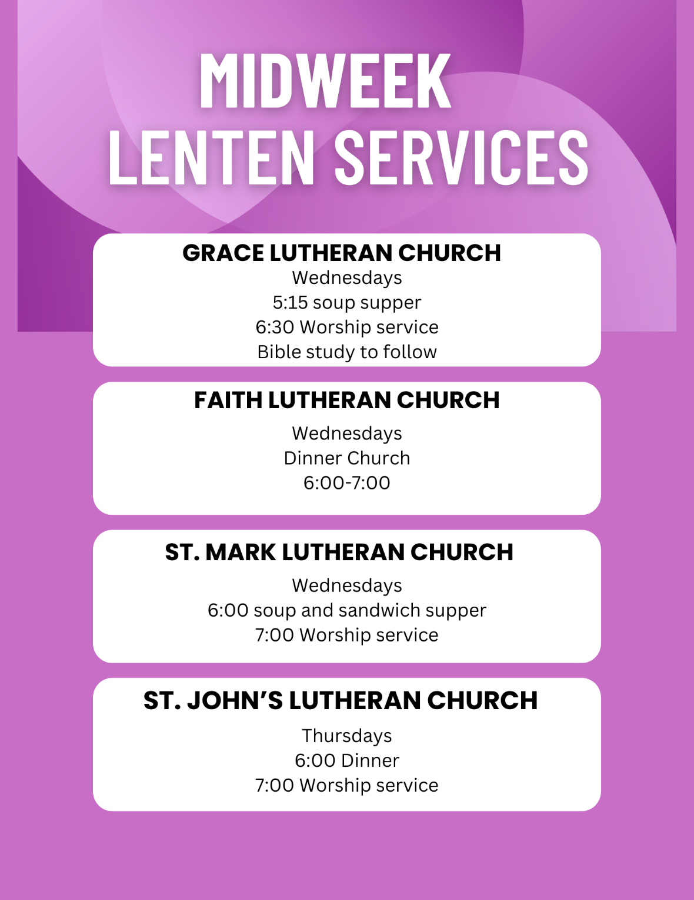

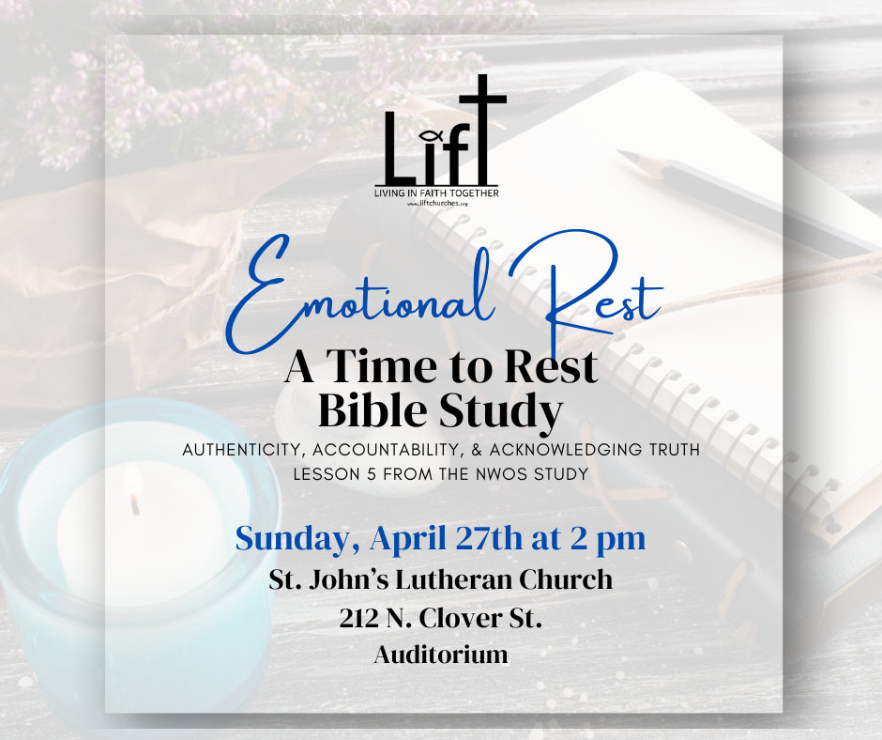

**Adult Summer Mission opportunity**

Many of us know the world was made a bit darker as much of North Carolina was impacted by Hurricane Helene. Pastor Bailey has been sharing conversations with Lutheran Disaster Response and with our Lutheran Camps in North Carolina. Not all of the details are set, but the invitation is open to gather names of those interested in a servant trip this summer. Here are some of the slightly confirmed details:

· Individuals must be 18 years or older.

· Most likely date is the week of June 29 through July 5

· The cost will likely be about $300 a person.

If you are interested in any way, please let Pastor Bailey (pastaorcbailey@gmail.com) know so that he can start to put the rest of the details of this great service opportunity together.

