**St. John’s News-June 2025**

**Embracing the Season**

*For everything there is a season, and a time for every matter under heaven (Ecclesiastes 3:1).*

And then summer came. School letting out. Graduations and confirmations. New opportunities. New challenges. Newborns and new life. New seasons of life in all sorts of different varieties. What a mystery… life! That third chapter of Ecclesiastes reminds us there is a season for everything under the sun. I wonder sometimes why an unseasonably warm day in winter somehow feels different (…at least a little bit different!) than a cool day in the summer. Our experience of certain kinds of realities in life seem to change according to the season.

Everything changes, present company included. For us to keep growing and living, we need to adapt to the changes around us, to know what season it is in life. It’s easy to become nostalgic, missing the glory days, and grieving the disappearance of the past. Whatever we might try to do though, the past has passed. There’s no going back. And it seems we’re always being welcomed and invited to live and work with the present season.

Ouch. Yeah, that can hurt. That whole paragraph you just read can hurt. These can be painful, saddening experiences in life, certainly. Sometimes, very painful. Change brings loss. And loss brings grief. And grief doesn’t usually like to play by any specific set of rules. What used to work for us, might not work so well in this season of life. What used to be new and exciting, might have lost its shine in this season. What maybe we found so enjoyable and moving in one season of life, might not bear the same fruit in this season of life.

Here's the gist. If we’re wise, we’ll find a faithful way of letting go of the attitudes and practices that have soured past their ‘use-by’ date. God continues to come to us in surprising, new ways, even today – even now – offering to fill us with the Holy Spirit’s peace and energy and new life. We’re never alone in the changing seasons. We find our bearings in this season, and every season, in and through the person of Jesus Christ. With Christ in us, with us, and all around us, we learn… we grow… we become fully alive again in this season.

With you in these changing seasons,

Pastor Matt Wheeler

**LIFT Outdoor Worship Service**

Come and worship on Sunday, June 29th, at 10:00am for our LIFT outdoor worship service. We’ll gather with our LIFT (Living in Faith Together) partners and friends at the amphitheater in downtown Fremont (209 S. Arch St.). Bring a lawn chair. Bring a friend. Bring an open heart and open mind, and maybe some sunscreen and shades or a tent. :-) We’ll have a fellowship hour with food and coffee from 9am until about 10am that morning. Everyone is welcome! If it rains, we’ll gather at one of our LIFT churches instead. (Please note: no worship services at St. John’s on Thursday night June 26th or Sunday morning June 29th. We’re moving it all to 10am at the amphitheater. Come and worship!)

**SAVE THE DATE!!**

**JUNE 29TH- MUDHEN’S GAME-4:00 PM**

**TICKETS- $15.00**

**CONGREGATIONAL REPORT**

**Joys:**

*-Ivy June Smith*, daughter of Curtis and Ashley (Weickert) Smith, was Baptized on Sunday, April 27th.

**Lifted in Prayer:**

*-The Family of Evelyn Swinehart*. FuneralService was held on Thursday, May 8th, at Wonderly Horvath Haynes Funeral Home.

*-The Family of Jason Culver* a Memorial service was held on Wednesday, May 7th. Jason was the grandson of Gerda Neumann.

-Pastor Matt officiated at the Memorial Service for *Cheryl Lynn Casebier*, on Saturday, May 10th.

**Women’s News****- IT’S COOKBOOK TIME AGAIN!** Have any favorite recipe/recipes? We’re putting together a new cookbook! We’ll be taking recipes until Sunday, **June 15th**. A basket will be at both entrances of the sanctuary, for you to drop your recipes into, or you can text a photo of your recipes to Sandy- at 419-967-0747. Please include your name and phone number, in case there are any questions concerning your recipe. Also include a note if you want the recipe returned to you. Thanks!!

***June Birthdays-*** Jena Humbert, Ben Weiker, Phyllis Mauk, Judith Peters, Nicho Rojas, Dee Dee

Kroeger, Brian Cummings, Ron Shawl, Sharon Woessner, Brandy Goodwin, Dale Johnston, Debbie Rakes, Mike, Willis, Ginny Schepflin, Jane Stotz, Dave DeFrance, Jodi Stevenson, Larry Behrendsen, Kelsey Schwochow, Nathan Baker, Scott Marsh, Lacy Schwochow, Connie Smith, Zeb Zucker, Brylee Zucker,

Abbott Boroff, Callie Balkovec, Kathy McCord, Linda Miller, Dave Fleming, Debbie Heberling, Kylie Peck, Clay Schwochow.

***June Anniversaries-*** Alex & Emily Boroff, Doug & Mindy Morris, Jim & Sandy Elfring, Gary & Sharon

Beatty, Jim & Connie Warner, Josh & Alli Smith, Barry & Brenda Hawk, Matt & Chrissy Wheeler,

Chad & Keisa Schwochow, John & Diane Fritz, Dan & Jane DeVanna, Clay & Lacy Schwochow, Kevin & Anne Weiker, Mark & Becky Humbert.

***July Birthdays-*** Dan Lease, Craig Hiser, Andrew Fisher, Robert James, Alesa Thurn, Carl Schwochow, Nancy Willis, Bill Ripple, Phil Sherick, Liam Kuehne, Cyle Schwochow, Sharon Beatty, Mary Ann McNair, Nora Smith, Harleigh Hill, Mindy Morris, Roxanna Kreider, Nikki Willis, Pat Fleming, Barb Held, Krista Kidd, John Shiets, Bella Myers, Karen Gerwin, Pam Kensler, Skylar Vargas, Amy Purney, James Wollenslegel, Barb Behrendsen, Ashley Bower, Jay Bowers.

***July Anniversaries-*** Tim & Mindy Brown, Jim & Nancy Willis, John & Brenda Hetrick, Mike & Mary Lou Warner, Terry & Janet Frey, Greg & Michelle Lindsay, Jim & Carol Biehler, Dick & Debra Wilson, Gilbert & Leslie Rojas, Dale & Janice Johnston, Dan & Jacquelyn Lease, Denny & LaDonna Michael, Jack & Nancy Whipple.

**SCHOLARSHIP AWARDS-** Congratulations to three of our exceptional young people who are receiving scholarships towards their continuing education. Those students are Tannah Bower, Jena Humbert and Macy Merrill. We look forward to sharing in prayer and encouragement for each of them as they seek God’s guidance in moving toward their future goals. The members of our Scholarship Committee are Pastor Matt, Dave Goodman, Debbie Grine, John Hetrick and Brenda Hetrick. It is with the prayerful and generous support of our congregation that we are able to offer this opportunity for financial support to our students. If you would at any time wish to contribute to this Education Grant Fund, please contact Karen in the church office for information. Our committee is so very grateful to each one of you. Thanks and may God Bless You.

**LUTHER LUNCH BUNCH** – On Wednesday, June 18th Luther Lunch will dine at Dianna’s Restaurant, Port Clinton. Meet in the church‘s back parking lot at 11:30 AM to carpool . Please let Carol or the church office know if you are joining us. All are welcome!!

A BIG Thank you to ***Bob Kusmer*** for making a new picture frame for our Parish House hallway! We can now continue to display our sketches of St. John’s former and current Pastors. Also to ***Brent Bachelder*** and ***Don Bixler*** for trimming the trees and bushes around the church landscaping areas!!

**GriefShare:**GriefShare will start up again on **Sunday, September 7, 5:30 - 7:00** in the **Parish House Lounge**.  Light snacks will be provided.  This is a 13 week course that helps you to deal with the loss of a loved one.  It utilizes a video, workbook, and small group discussion.  It is now designed that if you miss a Sunday, you are able to catch up that session by watching the video online. Please see Sharon Evans, Debbie Cummings, or Sue Lawrence with any questions.  You may also call the church office if interested, or just show up the first evening.

Sunday School: We are taking a break for the months of June, July, and August. We will start up again on Sunday, **September 7th**. More details to come. Thanks to Karen, Chad, Josh, and Keisa for all their help this past year. It has been a pleasure to work with your children. We pray for all the families to have a safe, happy, and restful summer. Thanks to Carol for all her work with the Adult Class. They have really appreciated her expertise as they continue to learn about God's Word.

**VACATION BIBLE SCHOOL: "ROAD TRIP! ON THE GO WITH GOD"**

**Hayes Memorial United Methodist Church,**

**June 23-26 from 5:30-7:30.**  A light meal will be provided from: 5:30-6:00. The theme is based on Joshua 1:9- "The LORD your God is with you wherever you go." Join us as we have fun, make new friends, and experience God's goodness together. Volunteer helpers and participants may register at: myvbs.org/LIFTFremont.

**Summer Parks Adventure: LIFT**is teaming up with various agencies in the city to help you have a fun filled summer at the parks from June 9- August 20.   LIFT will be hosting activities for Pre-K - high school events: art projects, games, and community BBQs. A few of the other groups that are included will be YOGA for all ages, Frisbee & Fingerprinting with the Fremont Police Department, Back to the Wild, Build with Habitat for Humanity for young people, etc.  Events are free!  Calendars will be available early in June.  Sue will be at the pre-school - 6th grade LIFT events.  Heather Hawn from Grace has been working with community leaders to put these events together. 

**JUNE DATES TO REMEMBER!!**

***June 1st –*** Graduation Day- Recognition of Graduates at 8:00 AM Service. *Reception following service*

***June 8th -*** Pentecost- Confirmation. *Reception in the Youth Room between Services*

12:30 PM-LIFT Board Meeting

***June 15th -***  Father’s Day- Baptism at 10:30 AM Service

***June 19th -*** Juneteenth- Office Closed

***June 19th & 22nd -*** Church Services move to the Auditorium

***June 23-26th-***  LIFT Vacation Bible School- at Hayes UMC

***June 29th-***  LIFT Outdoor Church- Downtown Amphitheater;

4:00 PM Mudhens Game

**DIRECT DEPOSIT OPTION**

Did you know that St. John’s offers a program through Thrivent Financial called Simply Giving? This program allows you to donate to the church by pre-authorizing a withdrawal from your checking or savings account. You determine the frequency of your automatic gift-weekly; semi-monthly, or monthly. Your gift is deposited directly into St. John’s bank account on the same day it is withdrawn from your account. Simply Giving is a reliable and safe way to put your generosity into ongoing stewardship. Because your gift is given consistently, you will not need to play “catch up” at year-end or worry about forgotten checkbooks or missed Sunday offerings. If you would like to take advantage of this program please call the church office.

**BACKPACK BUDDIES  2024 – 2025**

               For the ’24-’25 school year the LIFT Backpack Buddies provided 751 bags containing meal and snack items to 99 children from 28 families from Lutz Elementary.

            On average 50 bags were packed each packing day.  The approximate average value per bag was $6.42.  The total value of all packed bags was $4,822.45.

            The Backpack Buddies volunteers thank you so much for your generosity financially and especially for your donations of items for the backpacks. They were greatly appreciated.

            We plan to be back in the fall to begin year #4 of providing food for families in need.

            Meanwhile please keep our Blessing Box in mind when you do your shopping.  Karen distributes 35-45 bags per week to those in need.  The Blessing Box tub is in the elevator entrance of the Parish House. Thank you to all of you for your generous support and to Abigail Circle who also continues to support this ministry.

If anyone would like to use their Thrivent gift card for the Backpack Buddies or the Blessing Box, let us know. It only takes a few minutes to request a gift card and you can request 2 cards per year; each are worth $250.00.

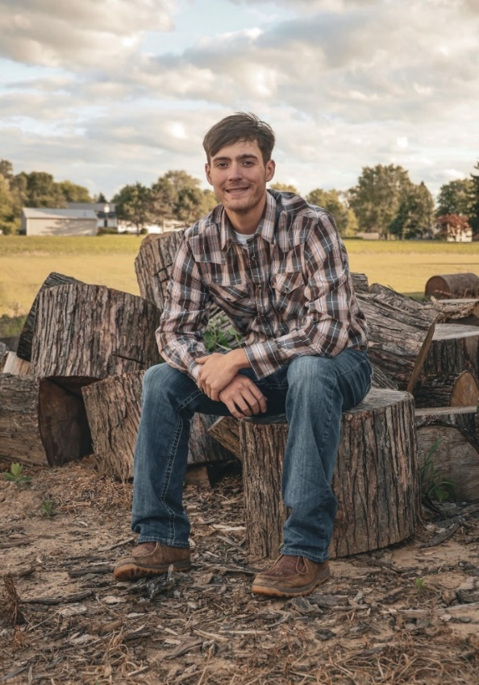***Congratulations to our Graduates!!***

**Andrew Fisher**

**Andrew is the son of Chad and Casey Fisher. He plans to continue to work in the electrical field, currently he works for M and M electric.**

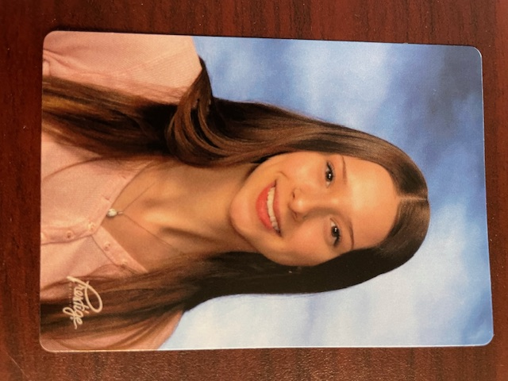

**Adelaide Weiker**

Addie is the daughter of Kevin and Anne Weiker.

After graduation she plans to attend BGSU to study art education.

**Alex Frasure -**Alex is the son of Gilberto &Leslie Frasure Rojas. He has graduated in Electrical Trades from Vanguard Sentinel (Old Fort).

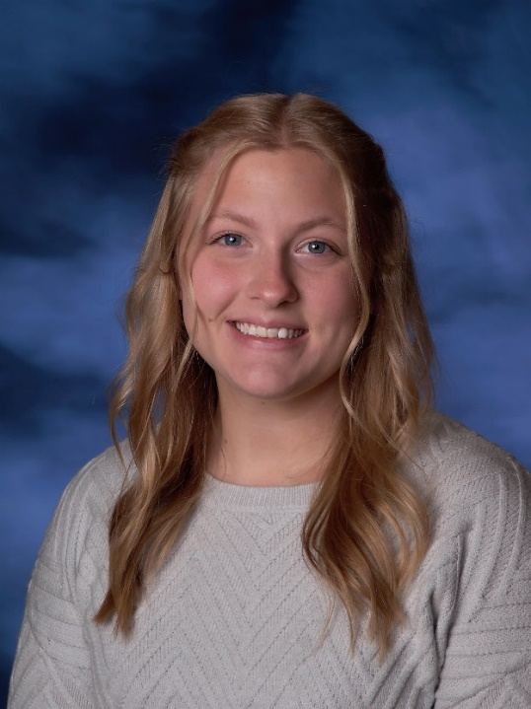**Morgan Harris**

**Morgan graduates from Fremont Ross High School. She is the daughter of LaRae Bryant. Morgan wants to see the world and has decided to join the military. She has chosen the Air Force.**

**Zeb Zucker –**

Zeb is the son of Robert and Nicole Zucker, he is going into the workforce, wanting to be a pipe fitter for welding. He'd like to go on and earn his journeyman's card while working for the Local Fifty union.

**Harleigh Hill- is the daughter of Katy Hill.**

**Kylie Peck-**is the daughter of Brent Tooman and Leslie Ferguson. Kylie will be joining the military.

**We wish all our graduates the very best and my God bless them as they continue their journey.**